**Group #2 Project Lab: POI Layers, GEO Map, Time Series, Bar Chart and Heat Map­ in SAC**

Carolina Gonzalez, [cgonz264@calstatela.edu](mailto:cgonz264@calstatela.edu)

Miguel Magana, [mmagan51@calstatela.ed](mailto:mmagan51@calstatela.ed)

Marco Rodas, [mrodas13@calstatela.edu](mailto:mrodas13@calstatela.edu)

Yocelyne Gomez, [ygomez5@calstatela.edu](mailto:ygomez5@calstatela.edu)

Jeff Block, [jblock@calstatela.edu](mailto:jblock@calstatela.edu)

California State University Los Angeles

## OBJECTIVE

This activity provides opportunity to understand economic and business impacts of bike lanes on businesses we look to the public data provided by the city of Los Angeles. You will explore data engineering to acquire, transform, and model data for data analysis in SAP Analytics Cloud. It allows you to explore some of the various visualization and Timeseries analysis functions of SAC.

## ACTIVITIES

* Import and prepare data
* Create Models
* Analyze and interpret output from models
* Create a story using responsive pages
* Create Point of Interest Layers
* Create a geo map with layers.
* Use linked analysis to link components of the stories
* Create a time series analysis with forecast
* Create a Bar Chart
* Create a Heat Map

## SOFTWARE PREREQUISITES

* SAP Analytics Cloud with Predictive Scenarios
* Microsoft Excel

## DATA SETS

* ActiveBusinesses.xlsx
* ClosedBusinesses.xlsx
* BikeLanes.xlsx
* SantaMonica.xlsx
* TimeSeriesData.xlsx

## SCENARIO

You are a member of Group 2 and are fascinated by Road Bikes. You are outside an ice cream shop staring at your Trek and wondering how many other ice cream shops get bikers stopping by. You are currently enrolled in a data analytics course and realize that this was an opportunity to explore your knowledge of SAP (SAC). You decide to include your Team in the question of the possibility of bicycle infrastructure playing a role in supporting/insulating local businesses from closure and the potential positive economic impact of bike lanes on businesses.

1. Creating the Model

## Steps:

1. Open a web browser and go to SAP Analytics Cloud (SAC) <https://higher-education.us10.sapanalytics.cloud/sap/fpa/ui/app.html>
2. Log in to SAP Analytics Cloud (SAC)
3. Click on menu and Select My Files
4. You will see the folder named folder named CalStateLA, then BUS5100 as a subfolder. That is, Select: CalStateLA > BUS5100Spr2022.

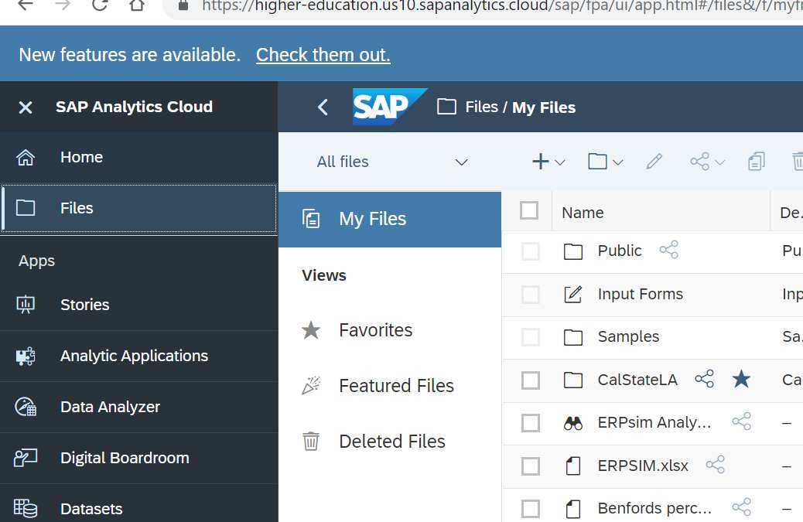

1. Select folder labeled “Group Project 2”
2. You will see a list of files when you click on the folder.
   1. Download each of these files to your computer in a folder where you can locate them.

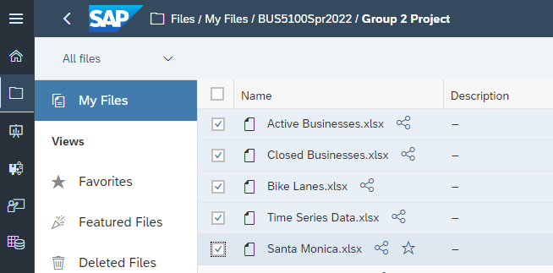

1. Create a Dataset.
   1. From the left menu bar, select the menu **Data Set**.
   2. Under Create New, click on From a CSV or Excel File.

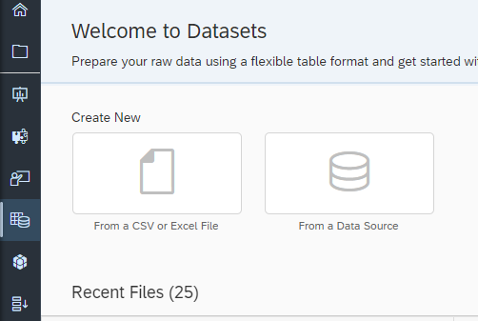

Importing a CSV into SAC

* 1. Click on “Select Source File” and locate the folder where you downloaded the Excel files from STEP 6. Follow the same path.
  2. Select “*Active Businesses.xlsx*” and click open.
     1. Use first row as column headers should be selected as default.
  3. Click Import.

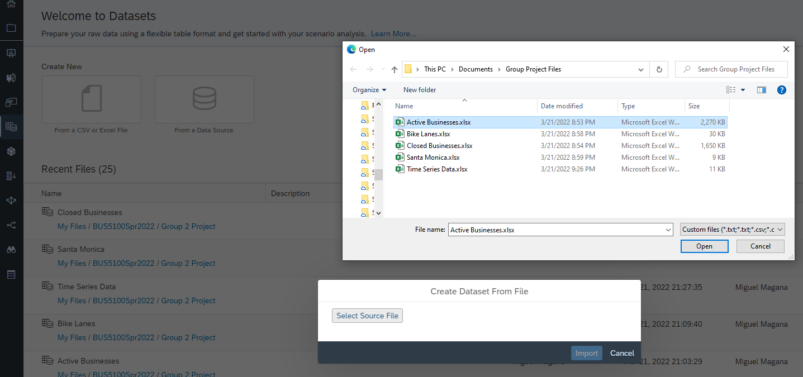

Selecting Source File

* 1. 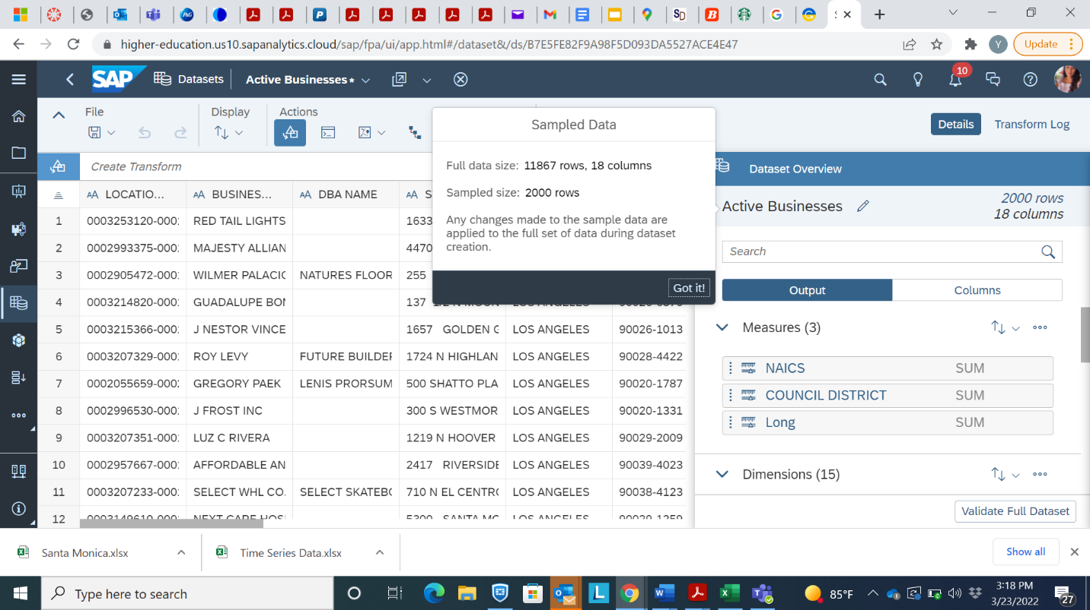Save the file under your folder.
     1. This is a large file so it may take a while to upload.
     2. Message “Sample data” – click Got it
     3. The Dataset will be saved with your other files and is available for use for other analyses.

1. Click on the “…” next to “Long” under Measures and select Change to a Dimension.

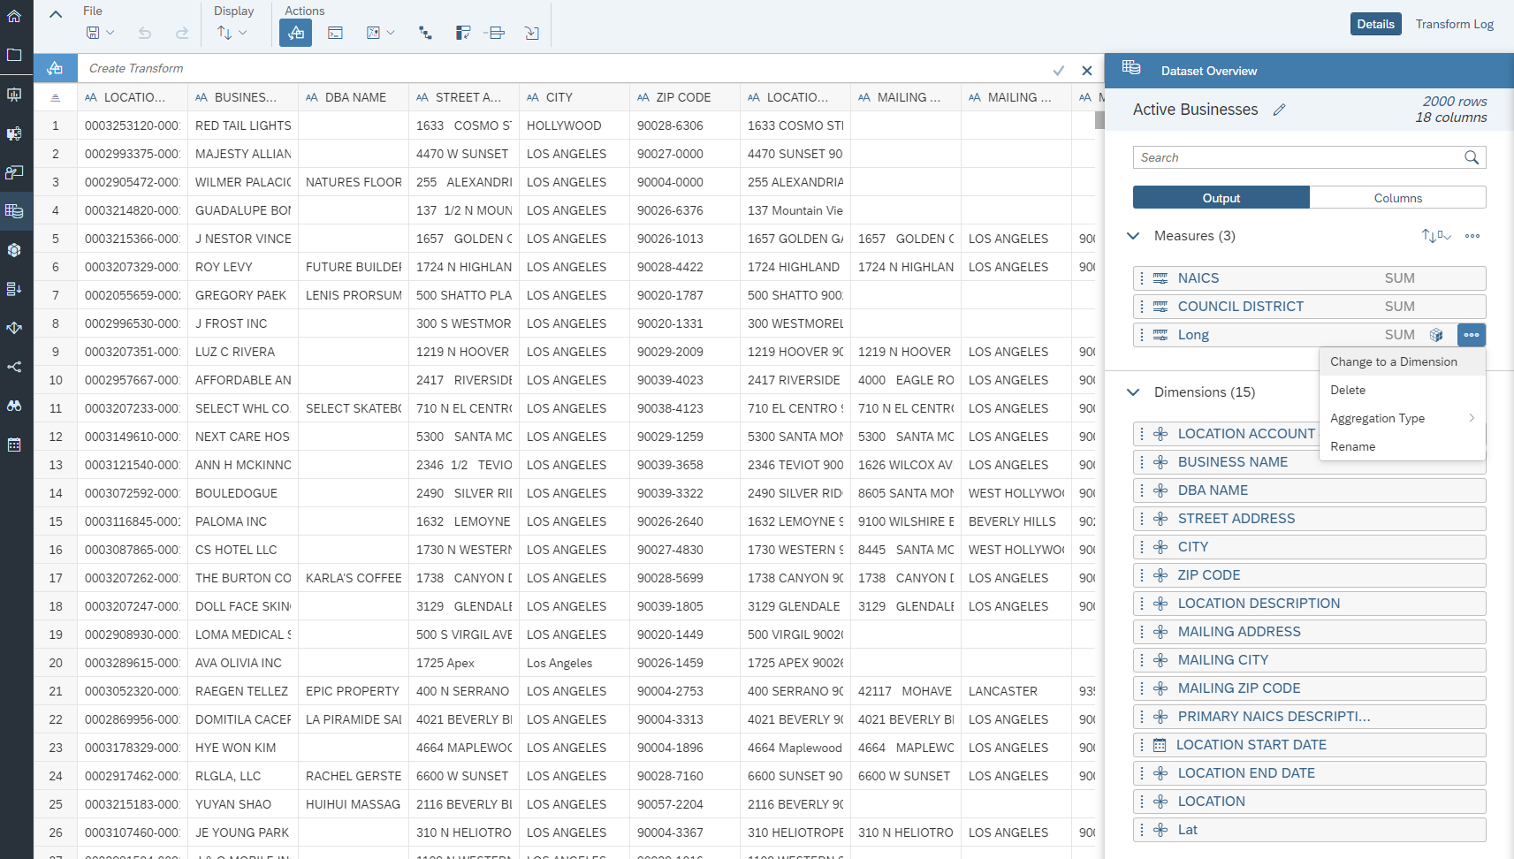

1. Under Actions Click the Geo Enrich Icon, then click Coordinates.

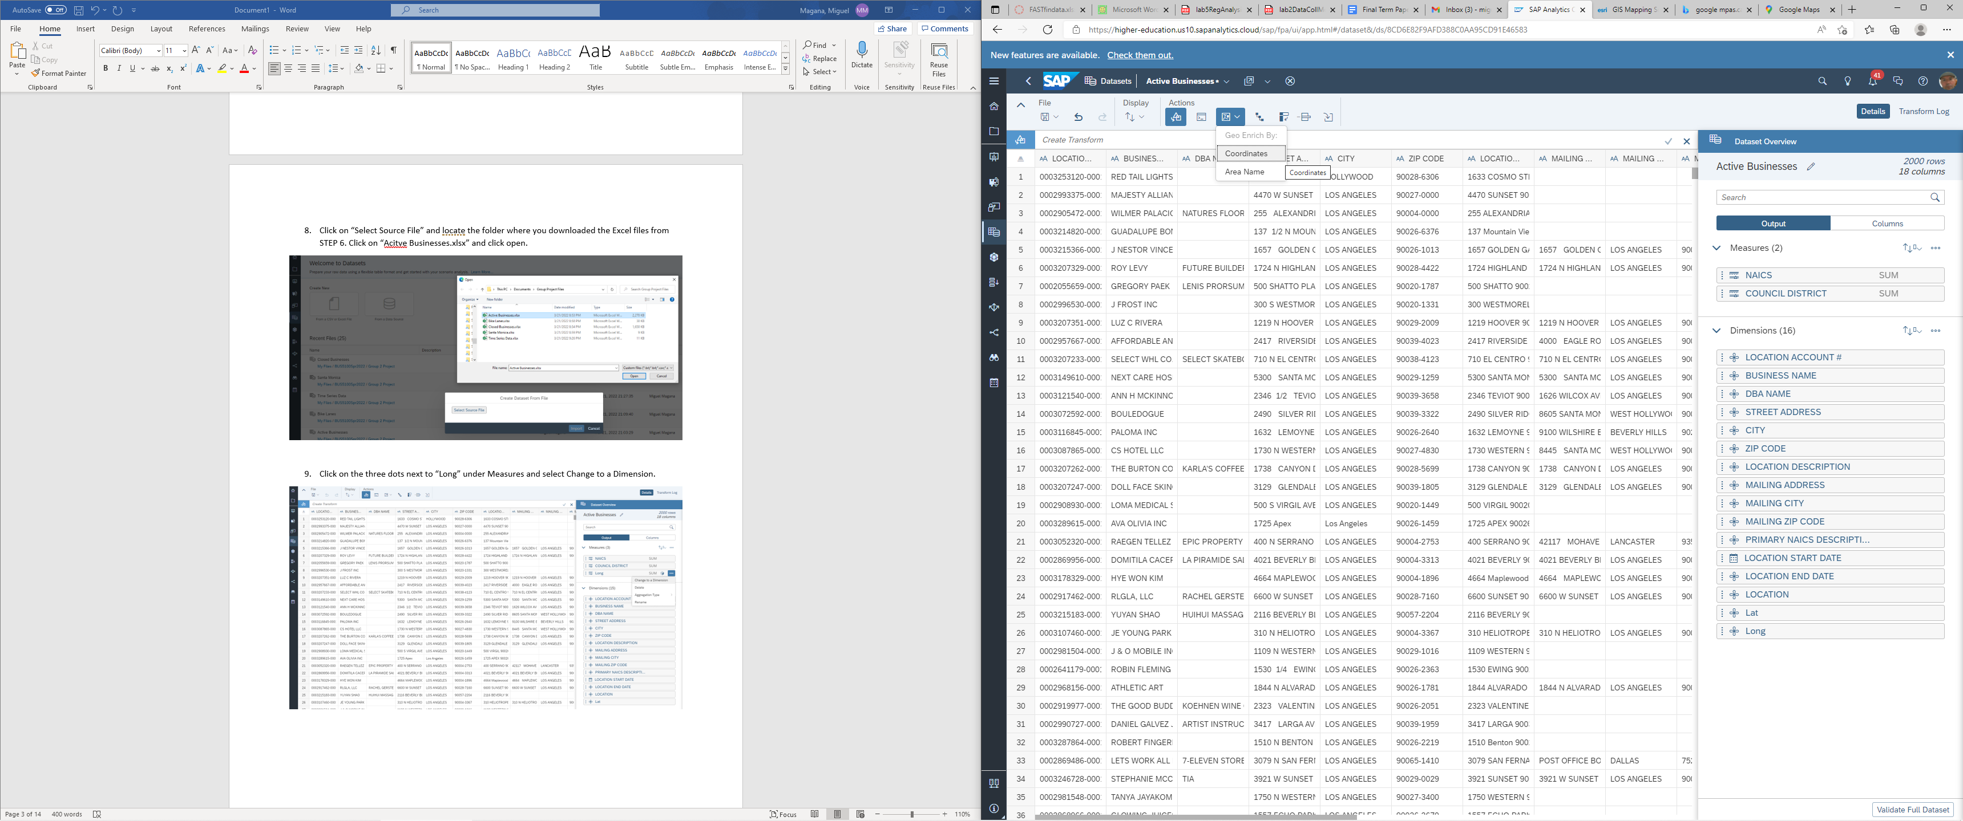

1. Under Dimension Name type in “Active Businesses.”
   1. Make sure there is no space in the Dimension Name
   2. Ensure Lat and Long are selected on the drop-down menus for Latitude and Longitude.
   3. Click “Ok”
   4. Click the Save icon under File. 

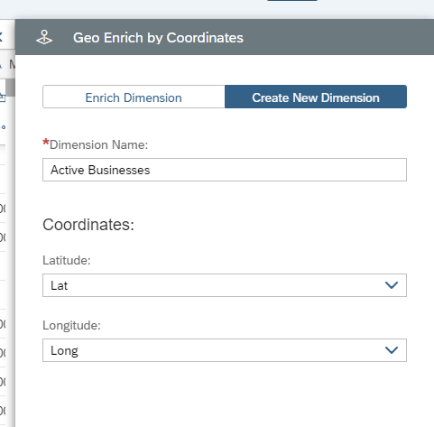

Make sure this gap doesn’t exist

**NOTE: Remember to save your data as you make changes**

1. Click the Data Sets icon 
   1. Repeat Steps 7 through 10 for the file “*ClosedBusinesses.xlsx*”
   2. Save 
2. Return to Data Sets Menu.
   1. Under Create New, click on From a CSV or Excel File.
   2. 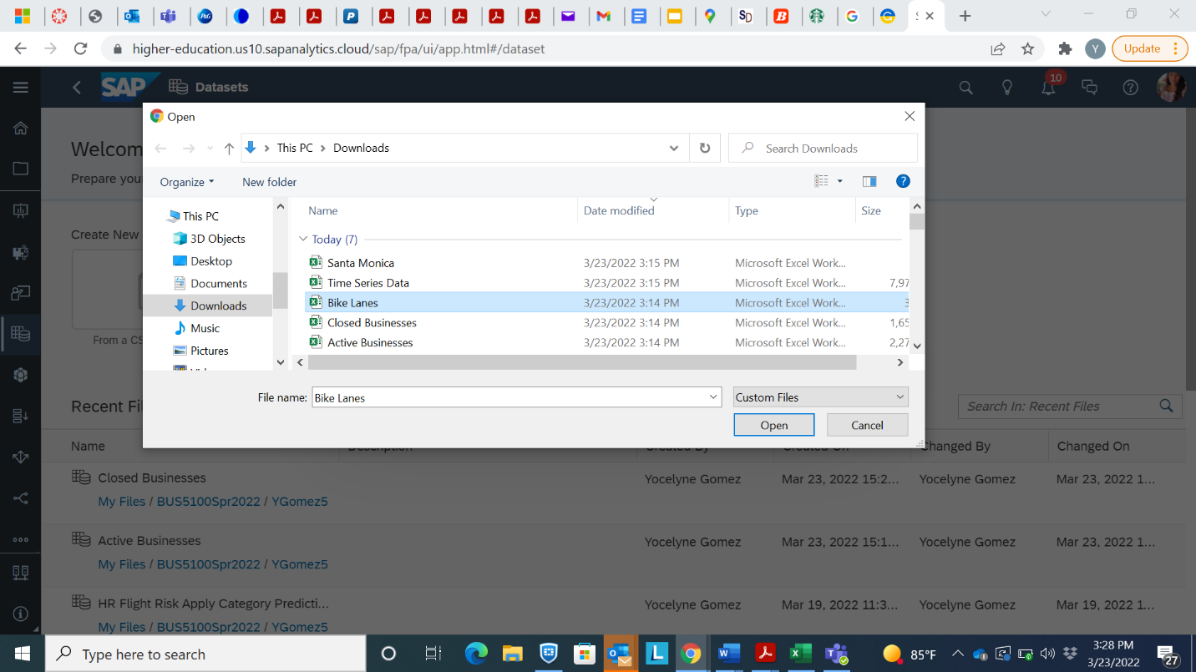Locate the file “*BikeLanes.xlsx*”
   3. Import file
   4. Change all Measures to Dimensions

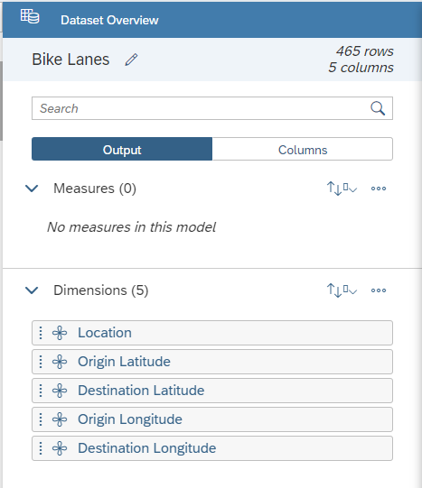

* 1. Click the GEO Enrich icon on the “Actions” tab
  2. Select Coordinates.
     1. Put “Origin” for Dimension Name
     2. Ensure that under Latitude and Longitude the “Origin Latitude” and “Origin Longitude” are selected from the drop-down menu.
     3. Select OK.

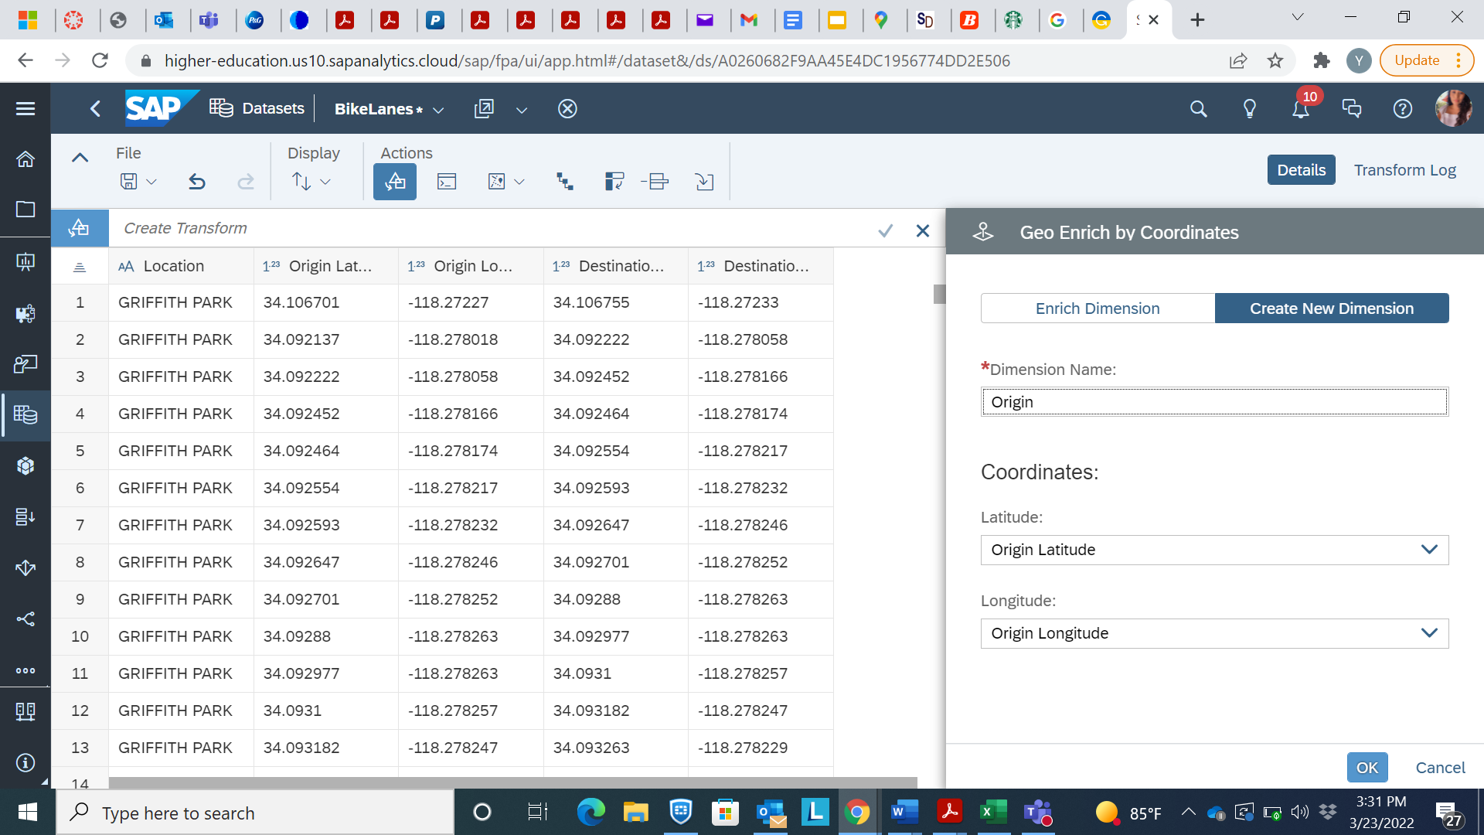

1. Repeat Step 12.
   1. Put “Destination” Dimension Name
   2. Destination Latitude and Longitude selected from the drop-down menu.
   3. Click OK

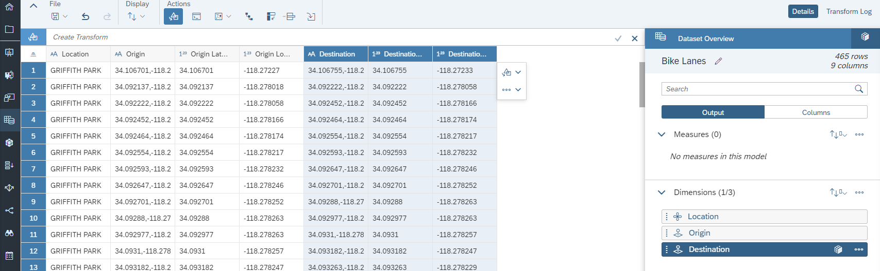

1. Return to Data Sets.
2. Under Create New, click on From a CSV or Excel File.
   1. Locate the file “*SantaMonica.xlsx*”
      1. All Measures should be Dimensions
      2. The coordinates should be Geo Enriched and titles “Origin” and “Destination” Once complete and saved it should look like this:

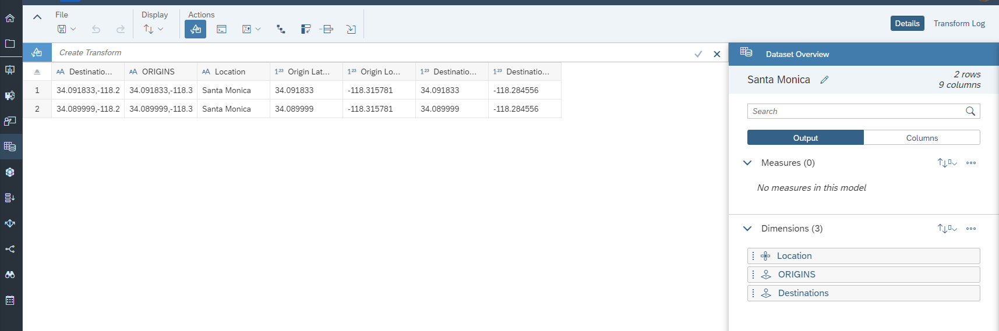

1. **Creating a “Points of Interest” Layer for the Geo Map.**
2. Navigate to the Modeler  page.
   1. If you move your mouse point over the menu “…” at the left navigator, you can select “Modeler”.

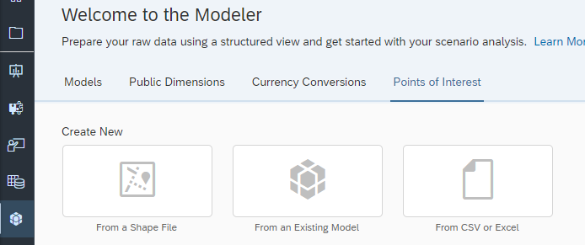

* 1. Select “Points of Interest” from the 4 options at the top
  2. Create New from CSV or Excel
  3. 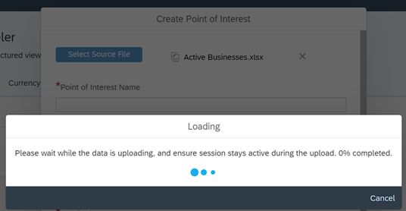Select Source File and locate the *“Active Businesses.xlsx”* file
  4. The Point of Interest Name will be “ActiveBusinesses”
  5. Select Lat and Long from the drop-down menus.
  6. Select Create.
  7. Save the Point of Interest File in the Group 2 Project Folder.

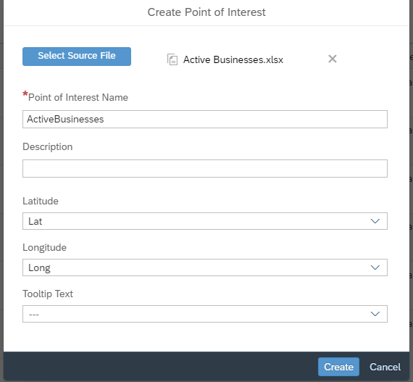

1. Repeat Step 16 for the file “ClosedBusinesses”.
   1. Select source File *“Closed Businesses.xlsx”*

_____________________________________________________________________________________

1. GEO Map
2. Click on the Stories  icon
   1. Click on Responsive 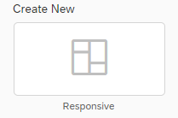
   2. From the “Insert” menu, select the “+” symbol
   3. Select GEO Map.
      1. Reference the Builder Tab
      2. Click Add Layer.

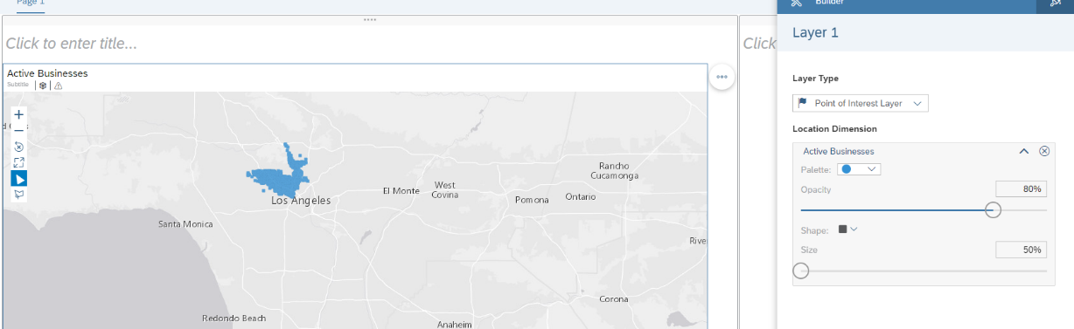 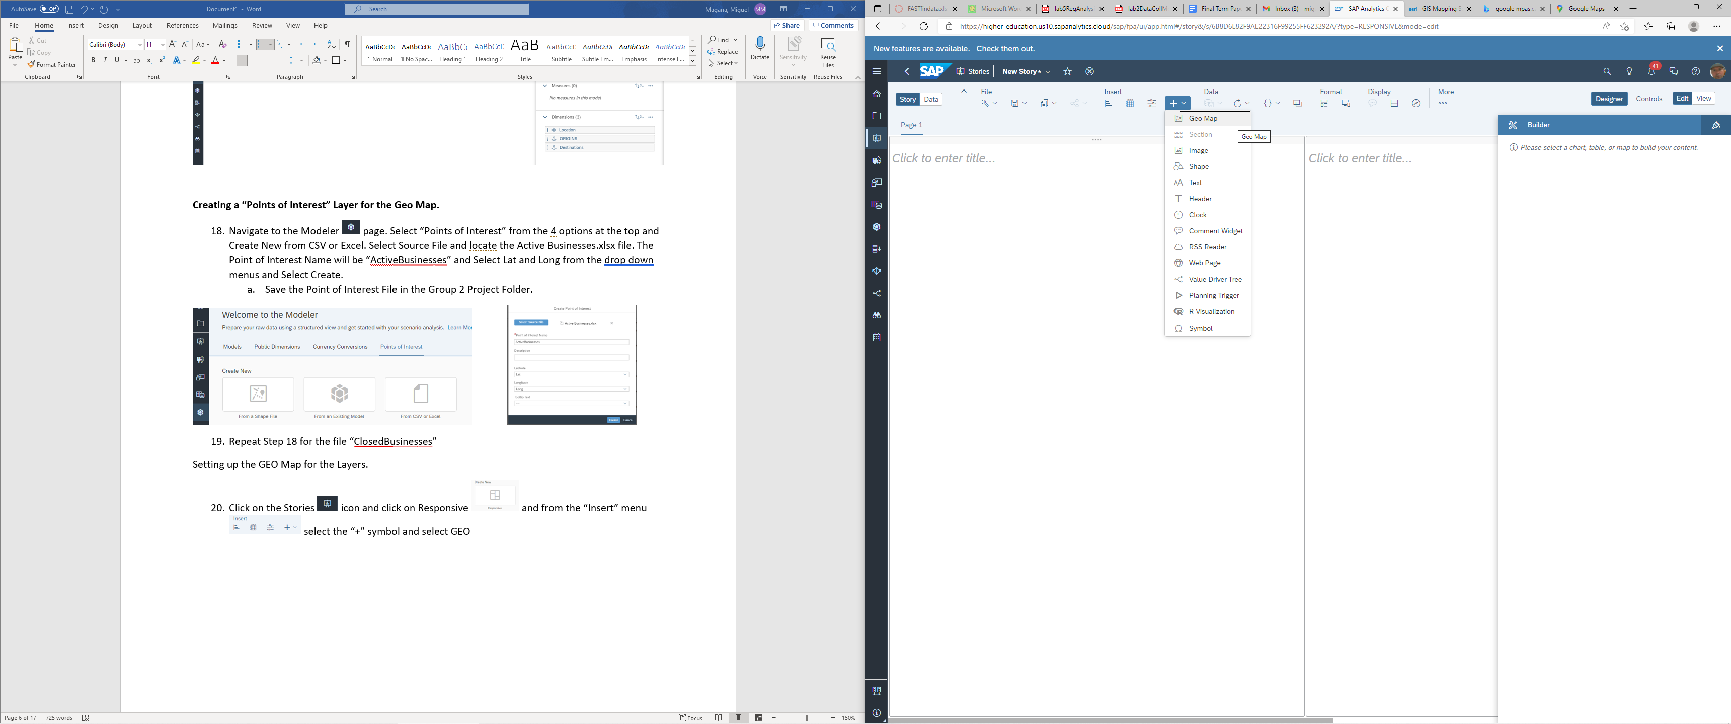 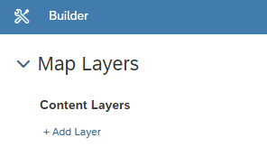

* 1. Select Point of Interest Layer.
  2. Click on Add Location Dimension
     1. Locate the “ActiveBusinesses” point of Interest file you create in Step 16
     2. Select “ActiveBusinesses”
     3. Adjust the Shape Size to 50% 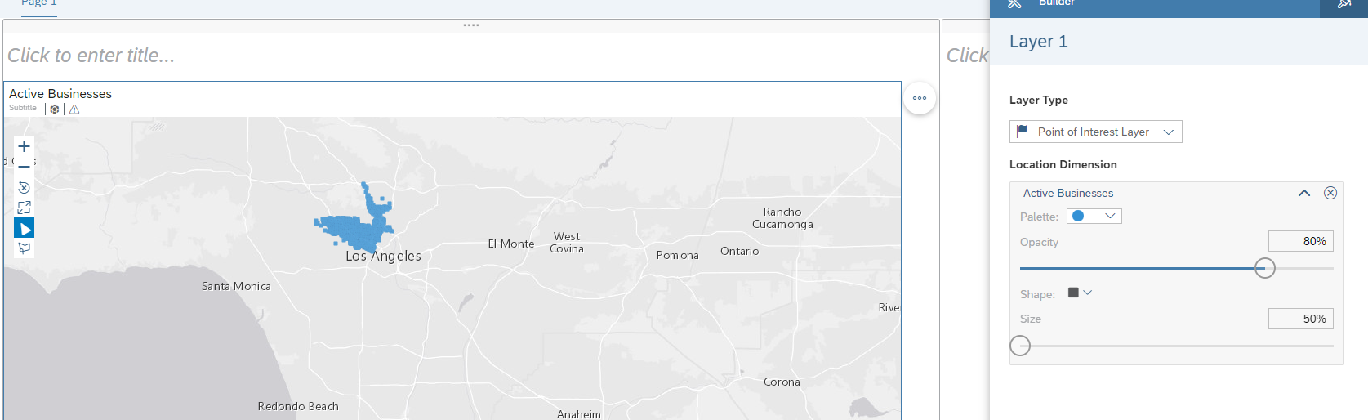
     4. The color is Blue with Opacity of 80% 

1. Repeat Step 1 section (c-e)
   1. This time utilize the “ClosedBusinesses” file you created in Step 17
   2. Adjust the Shape Size to 50% 
   3. Palette is Red and Opacity is 80%.
2. Add a Layer – Layer type will be “Flow Layer”
   1. Click on the pencil to change the Data Source
   2. click “Select Other Model.”

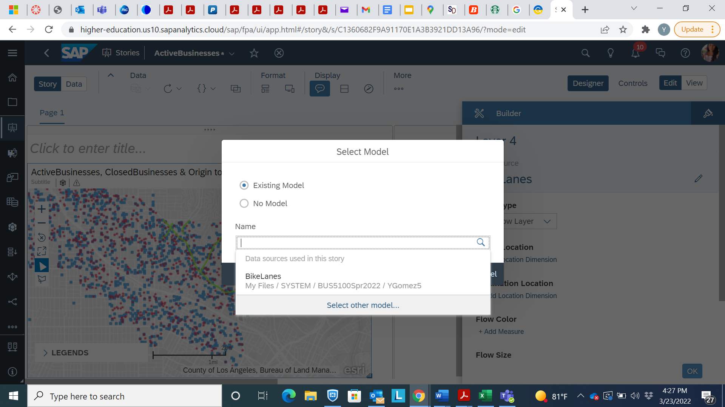

* 1. Locate the Data Set: “Bike Lanes” which you created in Step 12.

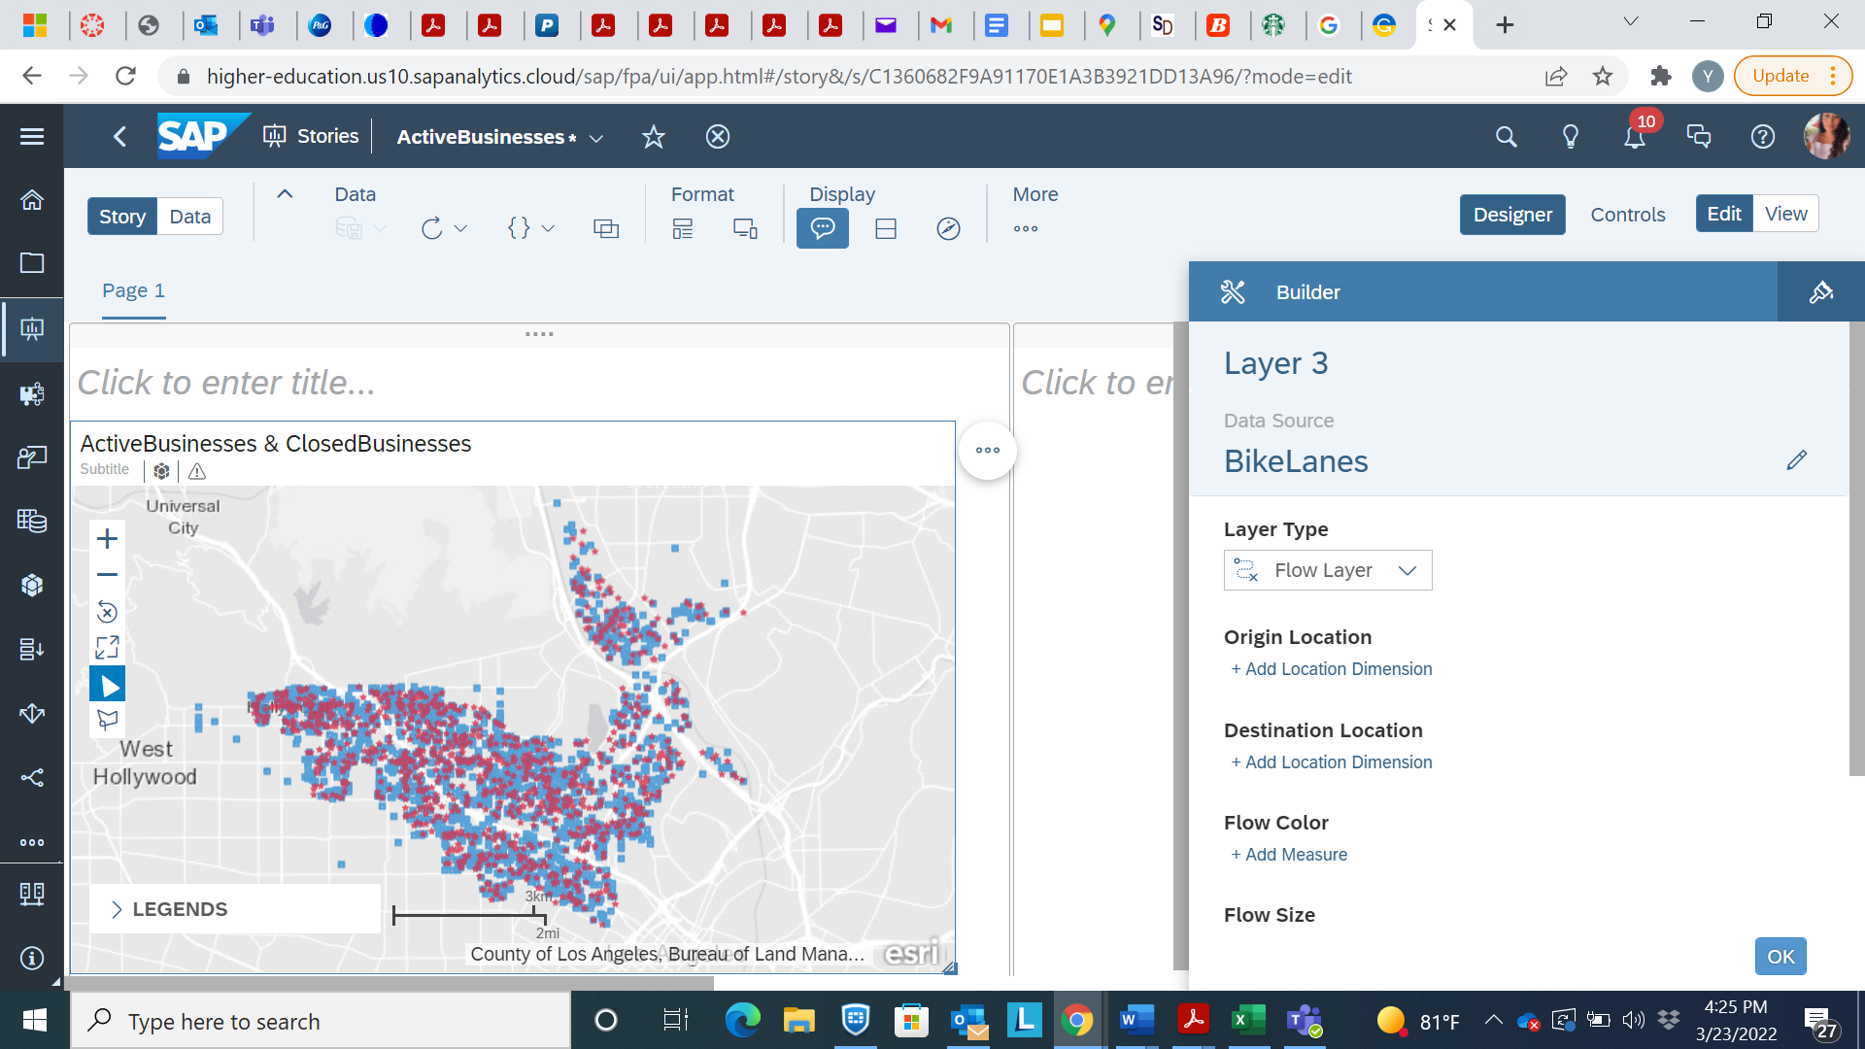

* 1. Origin Location:
     1. Click Add
     2. Select ORIGINS
  2. Destination Location:
     1. Click Add
     2. Select DESTINATION
     3. Change palette to Green
     4. Size to 300%
     5. Click OK.

1. Repeat Step 20
   1. Use Data Set “Santa Monica”
   2. Palette color Red
   3. Size 300%
   4. Click OK
2. Title this graphic: “Active and Closed Businesses 2016 to 2021”
3. Save your Data

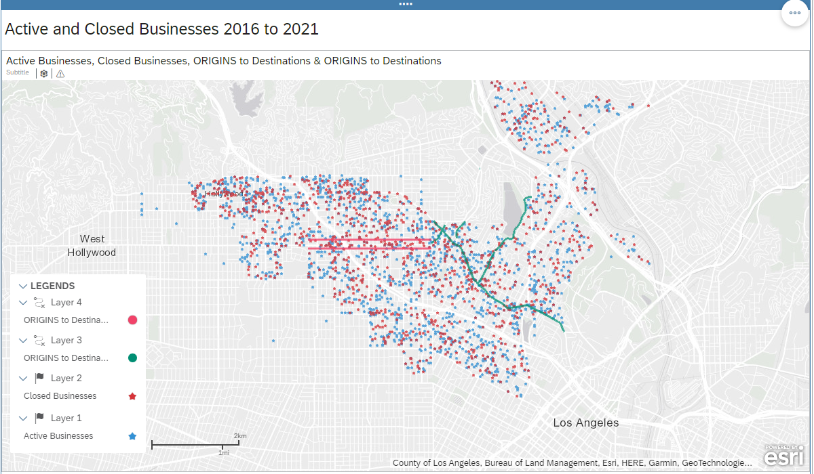

_____________________________________________________________________________________

1. Time Series
2. Add a new page then insert a new chart. Locate the Data Source you created labeled “Time Series Data.”

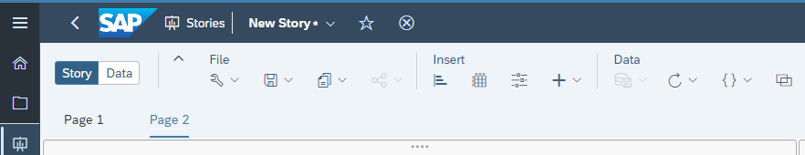

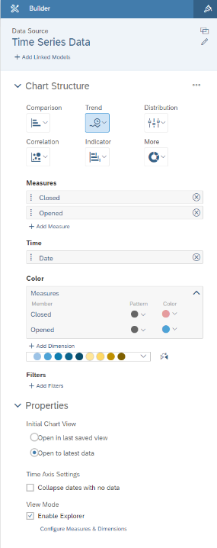

1. On Chart Structure, under Trend, Click on Time Series.
   1. Add Measures: Closed and Opened
   2. Time: Add the Dimension Date
   3. Change the Closed color to Red
   4. Ensure Enable Explorer is checked under View Mode.
   5. Hit OK
2. On The Chart, click: Set Drill 
   1. Select: “Quarter”
   2. Click on “…”
      1. Select Add –> Forecast –> Advanced Options –> Triple Exponential Smoothing.
      2. Title the Chart: **“Time Series with Prediction”**

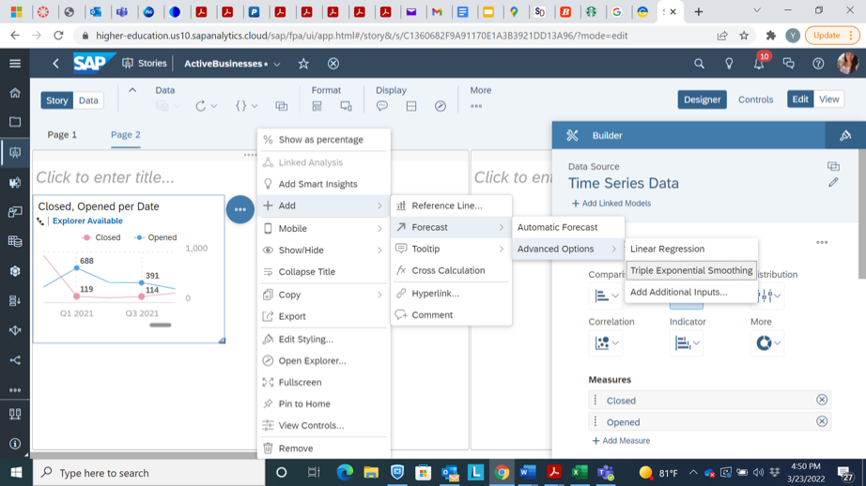

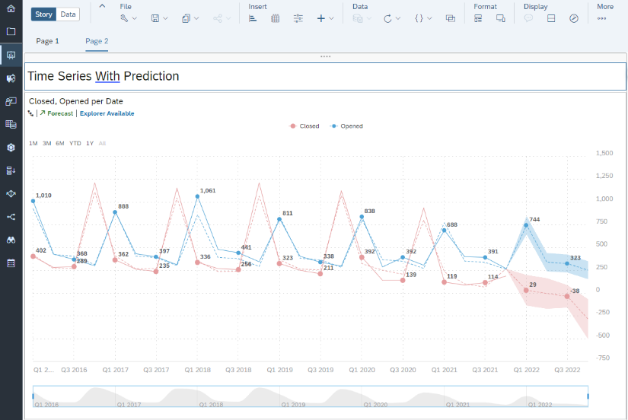

1. Bar Chart
2. Add an additional Page,
   1. Click on Responsive
   2. Insert a chart.
      1. Under Chart Structure, Comparison, Select Bar/Column
      2. Use the same Measures and Dimension as the Time Series Chart
      3. Once Date is selected as the dimension, you should see the image below two bars with figures above.

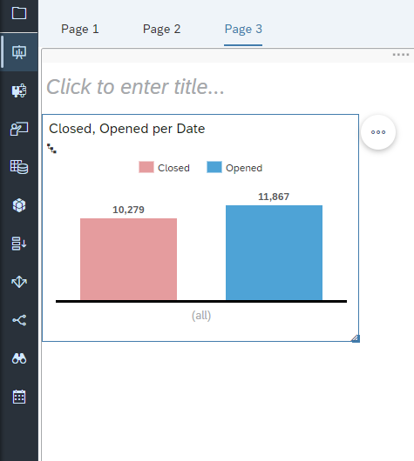

1. Under the Recommended Comparisons (5) drop down menu,
   1. Select Previous Quarter Date.
   2. Expand the Chart
   3. Title the Chart: “Opened/Closed Comparison”

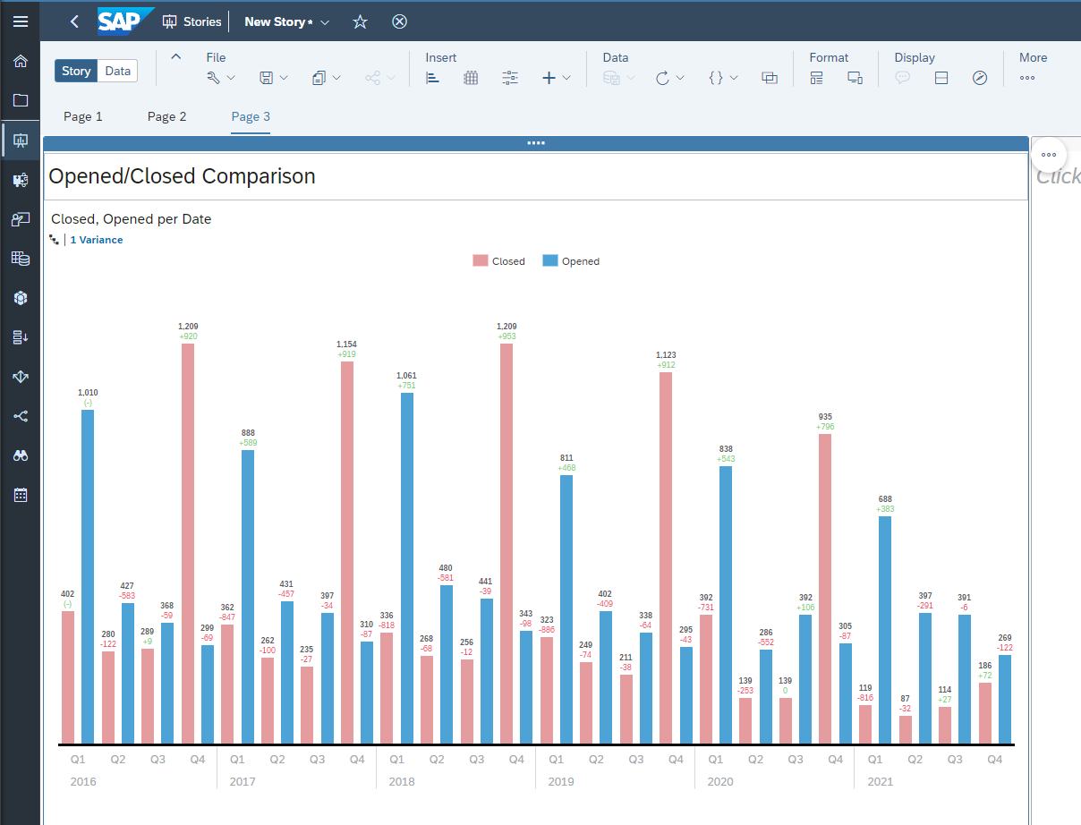

_____________________________________________________________________________________

1. Heat Map
2. Select Page 1, on the drop down select Duplicate.
3. Rename the Duplicate Chart: “Closed Businesses 2016 to 2021”
4. Under Content Layers, delete the Point of Interest Layers (Layer 1 and Layer 2)
5. Add a Layer
   * 1. Layer Type: Select Heat Map Layer
     2. Change Data Source to “Closed Businesses”
6. Location Dimension: (Closed Businesses)
7. Heat Map Color: Select Council District
   * 1. Adjust the colors of the Bike Lanes and Santa Monica Flow Layers to contract the Heat Map Color

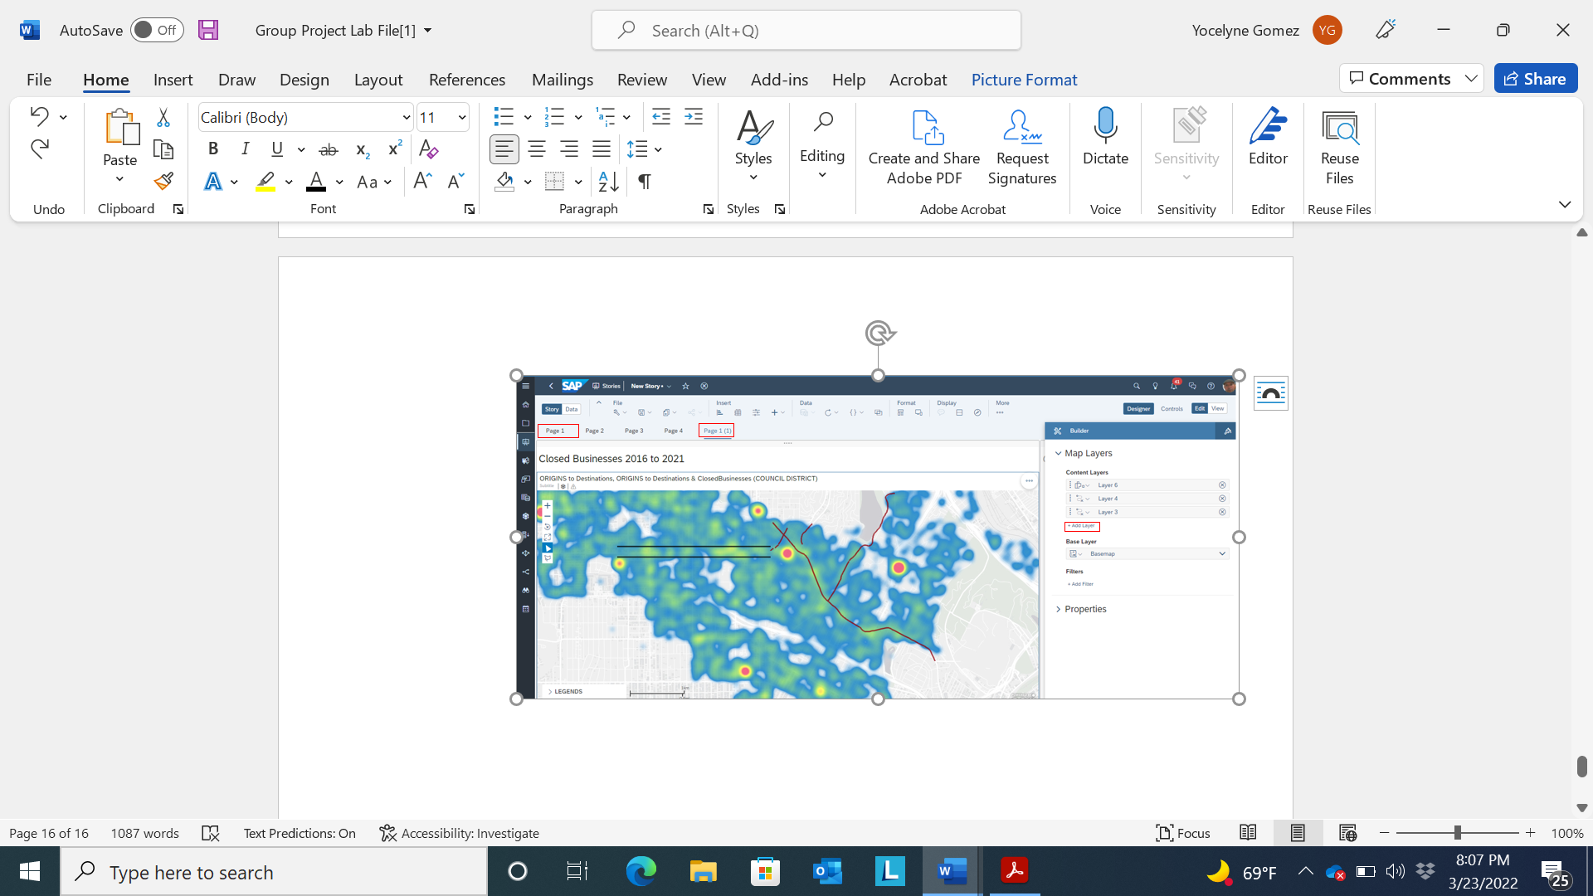

1. Geo Map (2)
2. Duplicate Page 1 by selecting the drop down and selecting Duplicate. Once the map is duplicated. Zoom into the area containing the bike lane and non-bike lane area.
   1. Click the Polygon Filter and select Poygon Filter.
   2. Draw a polygon around the bike lane and non-bike lane area estimating 500’ setback

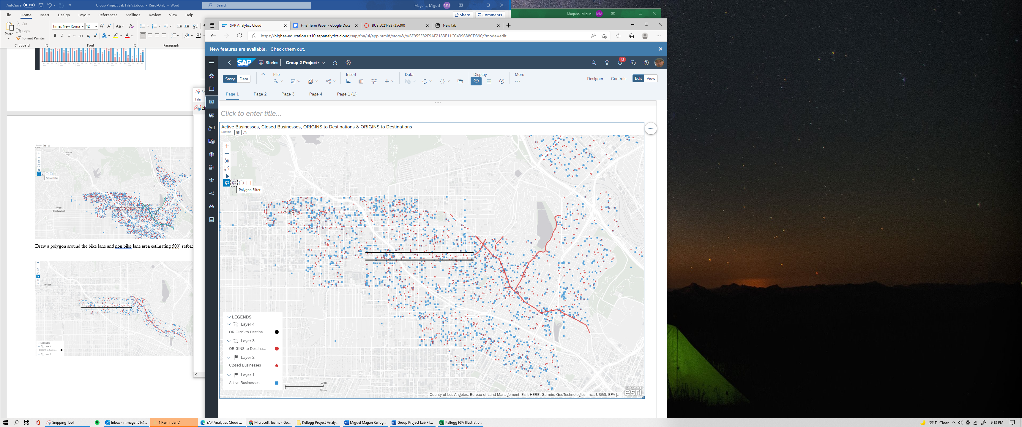

* 1. Select Filter Selected Data Points

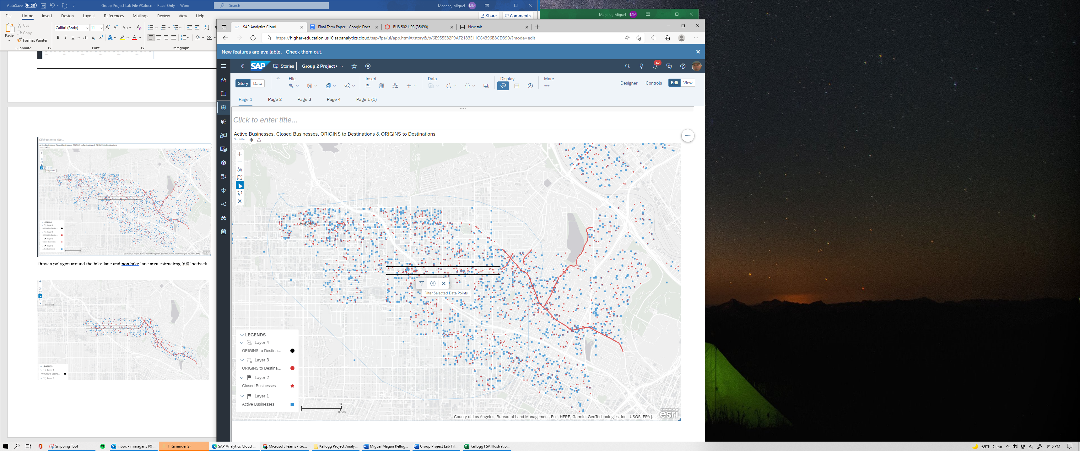

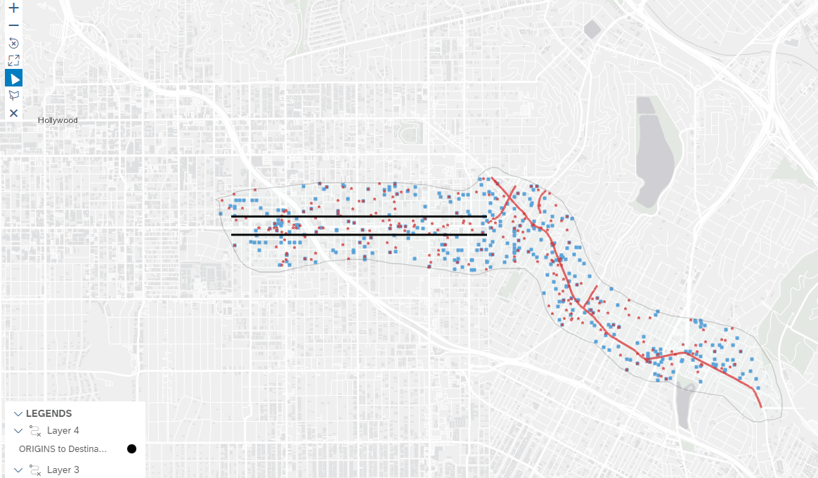

This is the end of the lab